**Data test:**

| Inputs: | Expected Outputs: |
| --- | --- |
| 12°C | 53.6°F |
| 78.3°F | 25.7222°C |
| 92.9°F | 33.8333°C |
| 101.5°F | 38.6111°C |
| “See Statistics” | Celsius:  12  25.7222  33.8333  38.6111  Fahrenheit:  53.6  78.3  92.9  101.5  Avg:  81.575°F  27.5417°C  Mode:  85.6°F  29.7778°C |

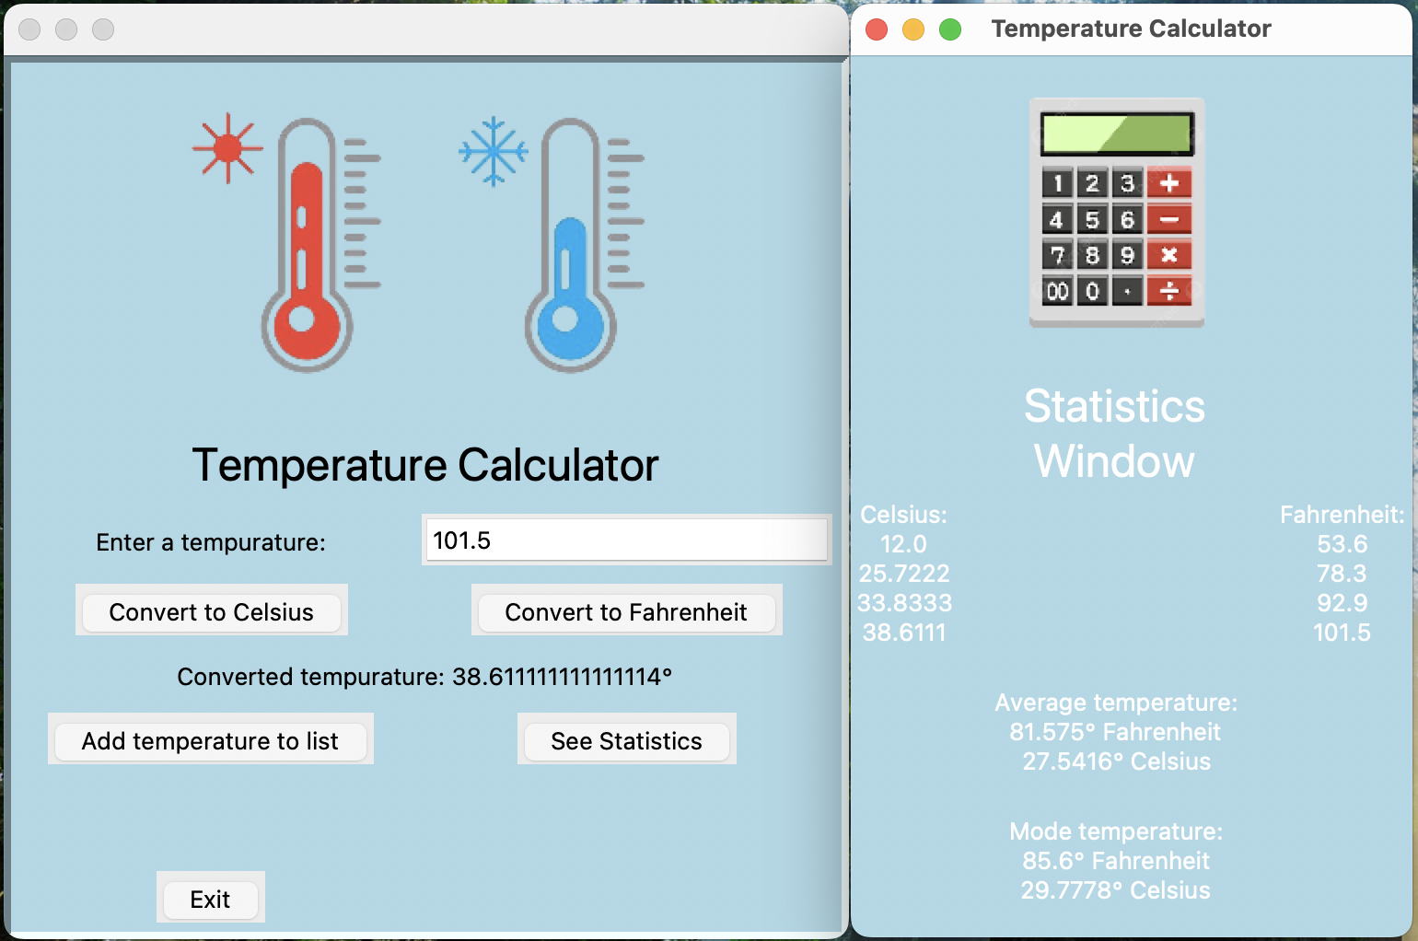

When I ran this data, I was happy to see that my project gave me the correct results the first time. Nothing needed fixing.

**Documentation / User’s Manual:**

**Section 1.0: Introduction**

Hello, and welcome to the Temperature Calculator application! With this piece of software, you can:

* Convert temperatures between celsius and fahrenheit
* Save temperatures to a list to calculate the average and mode temperatures
* View the aforementioned calculations along with a list of all the temperatures saved, all displayed in both celsius and fahrenheit

This software is useful in scientific environments, as you can find the average temperature of a data set.

**Section 1.1: Entering temperatures**

To enter a temperature, click on the box to the right of the label “Enter a temperature:”. Then, click on either the “Convert to Celsius” or the “Convert to Fahrenheit” button to view the resulting conversion, depending on what unit of measurement the temperature is in. If your temperature is in fahrenheit, convert it to celsius, and vice versa. Note that when entering temperatures, it is important to know what unit of measurement the temperature is in. A misunderstanding of the unit will lead to incorrect calculations.

**Section 1.2: Adding temperatures to the list and viewing statistics**

After entering the temperature and converting it, you can click on the “Add temperatures to list” button. This will save the temperature to both a fahrenheit and celsius list that can be viewed later and that is used for calculating the average and mode. Note that at least one temperature has to be entered to view statistics about the temperatures entered. To view the statistics, click the “See Statistics” button. This will open a second window that will display all the temperatures in fahrenheit and celsius, as well as the average temperature and mode temperature, both in fahrenheit and celsius.

**Section 1.3: Miscellaneous**

If you see an error message that says “Error: value entered wasn’t a valid number”, the value in the entry box is either blank or has unsupported characters in it. Make sure to only use characters 0-9 and decimals to avoid getting this error message. To exit the application, simply click the “Exit” button, or click the red button in the corner of the window.

**GitHub Link:** <https://github.com/Mitchell-Sch/FinalProject.git>